BABU BANARASI DAS
UNIVERSITY

2026-2027

SCHOOL OF COMPUTER APPLICATIONS
No SQL Project On
Hospital Management System Using MongoDB

Submitted to: Submitted by:
Mr. Harendra Singh Sejal
Department: BCA (DS & AI) Roll no: (24)
Date: 25th September 1250258406

1. CREATE DATABASE
MongoDB Query:
use HospitalManagement
Explanation: Creates or switches to the HospitalManagement database.



2. CREATE COLLECTION
MongoDB Query:
db. create Collection("Patients")
Explanation: Creates a collection named Patients.
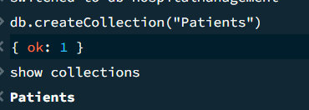
3. INSERT 50 patients
MongoDB Query:
db.patients.insertMany([
{patient_id:101,name:"Aarav Sharma",age:25,gender:"Male",disease:"Fever",doctor:"Dr. Amit",city:"Lucknow",fees:500},
{patient_id:102,name:"Priya Singh",age:32,gender:"Female",disease:"Diabetes",doctor:"Dr. Neha",city:"Kanpur",fees:800},
{patient_id:103,name:"Rahul Verma",age:45,gender:"Male",disease:"Blood Pressure",doctor:"Dr. Raj",city:"Lucknow",fees:700},
{patient_id:104,name:"Ananya Gupta",age:21,gender:"Female",disease:"Cold",doctor:"Dr. Amit",city:"Delhi",fees:400},
{patient_id:105,name:"Vivek Kumar",age:52,gender:"Male",disease:"Heart Disease",doctor:"Dr. Raj",city:"Kanpur",fees:1200},
{patient_id:106,name:"Sneha Yadav",age:29,gender:"Female",disease:"Migraine",doctor:"Dr. Neha",city:"Lucknow",fees:600},
{patient_id:107,name:"Rohit Mishra",age:38,gender:"Male",disease:"Asthma",doctor:"Dr. Amit",city:"Prayagraj",fees:750},
{patient_id:108,name:"Pooja Sharma",age:41,gender:"Female",disease:"Thyroid",doctor:"Dr. Neha",city:"Delhi",fees:900},
{patient_id:109,name:"Karan Singh",age:19,gender:"Male",disease:"Fever",doctor:"Dr. Amit",city:"Lucknow",fees:450},
{patient_id:110,name:"Neha Verma",age:35,gender:"Female",disease:"Diabetes",doctor:"Dr. Raj",city:"Kanpur",fees:850},
{patient_id:111,name:"Aditya Gupta",age:47,gender:"Male",disease:"Blood Pressure",doctor:"Dr. Raj",city:"Delhi",fees:750},
{patient_id:112,name:"Simran Khan",age:26,gender:"Female",disease:"Cold",doctor:"Dr. Amit",city:"Lucknow",fees:400},
{patient_id:113,name:"Mohit Yadav",age:56,gender:"Male",disease:"Heart Disease",doctor:"Dr. Raj",city:"Prayagraj",fees:1300},
{patient_id:114,name:"Riya Singh",age:30,gender:"Female",disease:"Migraine",doctor:"Dr. Neha",city:"Kanpur",fees:650},
{patient_id:115,name:"Arjun Sharma",age:43,gender:"Male",disease:"Asthma",doctor:"Dr. Amit",city:"Delhi",fees:700},
{patient_id:116,name:"Kavya Verma",age:24,gender:"Female",disease:"Fever",doctor:"Dr. Neha",city:"Lucknow",fees:500},
{patient_id:117,name:"Nikhil Kumar",age:36,gender:"Male",disease:"Diabetes",doctor:"Dr. Raj",city:"Kanpur",fees:850},
{patient_id:118,name:"Isha Gupta",age:28,gender:"Female",disease:"Thyroid",doctor:"Dr. Neha",city:"Delhi",fees:900},
{patient_id:119,name:"Manish Singh",age:50,gender:"Male",disease:"Blood Pressure",doctor:"Dr. Raj",city:"Lucknow",fees:750},
{patient_id:120,name:"Tanya Yadav",age:22,gender:"Female",disease:"Cold",doctor:"Dr. Amit",city:"Prayagraj",fees:400},
{patient_id:121,name:"Saurabh Sharma",age:39,gender:"Male",disease:"Asthma",doctor:"Dr. Amit",city:"Kanpur",fees:700},
{patient_id:122,name:"Muskan Verma",age:31,gender:"Female",disease:"Fever",doctor:"Dr. Neha",city:"Lucknow",fees:500},
{patient_id:123,name:"Deepak Gupta",age:48,gender:"Male",disease:"Heart Disease",doctor:"Dr. Raj",city:"Delhi",fees:1250},
{patient_id:124,name:"Nandini Singh",age:27,gender:"Female",disease:"Migraine",doctor:"Dr. Neha",city:"Kanpur",fees:600},
{patient_id:125,name:"Yash Kumar",age:34,gender:"Male",disease:"Diabetes",doctor:"Dr. Raj",city:"Lucknow",fees:800},
{patient_id:126,name:"Aditi Sharma",age:20,gender:"Female",disease:"Cold",doctor:"Dr. Amit",city:"Delhi",fees:400},
{patient_id:127,name:"Varun Yadav",age:44,gender:"Male",disease:"Blood Pressure",doctor:"Dr. Raj",city:"Prayagraj",fees:700},
{patient_id:128,name:"Shreya Gupta",age:33,gender:"Female",disease:"Thyroid",doctor:"Dr. Neha",city:"Lucknow",fees:850},
{patient_id:129,name:"Harsh Singh",age:58,gender:"Male",disease:"Heart Disease",doctor:"Dr. Raj",city:"Kanpur",fees:1400},
{patient_id:130,name:"Pallavi Verma",age:29,gender:"Female",disease:"Fever",doctor:"Dr. Amit",city:"Delhi",fees:500},
{patient_id:131,name:"Abhishek Kumar",age:40,gender:"Male",disease:"Asthma",doctor:"Dr. Amit",city:"Lucknow",fees:750},
{patient_id:132,name:"Sakshi Gupta",age:23,gender:"Female",disease:"Cold",doctor:"Dr. Neha",city:"Kanpur",fees:400},
{patient_id:133,name:"Ravi Sharma",age:51,gender:"Male",disease:"Diabetes",doctor:"Dr. Raj",city:"Delhi",fees:900},
{patient_id:134,name:"Komal Singh",age:37,gender:"Female",disease:"Migraine",doctor:"Dr. Neha",city:"Lucknow",fees:650},
{patient_id:135,name:"Akash Yadav",age:46,gender:"Male",disease:"Blood Pressure",doctor:"Dr. Raj",city:"Prayagraj",fees:750},
{patient_id:136,name:"Payal Verma",age:26,gender:"Female",disease:"Fever",doctor:"Dr. Amit",city:"Kanpur",fees:500},
{patient_id:137,name:"Tarun Gupta",age:42,gender:"Male",disease:"Thyroid",doctor:"Dr. Neha",city:"Delhi",fees:850},
{patient_id:138,name:"Megha Sharma",age:30,gender:"Female",disease:"Asthma",doctor:"Dr. Amit",city:"Lucknow",fees:700},
{patient_id:139,name:"Rohan Singh",age:55,gender:"Male",disease:"Heart Disease",doctor:"Dr. Raj",city:"Kanpur",fees:1300},
{patient_id:140,name:"Divya Kumar",age:25,gender:"Female",disease:"Diabetes",doctor:"Dr. Neha",city:"Delhi",fees:800},
{patient_id:141,name:"Aman Yadav",age:49,gender:"Male",disease:"Blood Pressure",doctor:"Dr. Raj",city:"Lucknow",fees:750},
{patient_id:142,name:"Nisha Gupta",age:34,gender:"Female",disease:"Fever",doctor:"Dr. Amit",city:"Prayagraj",fees:500},
{patient_id:143,name:"Vikas Sharma",age:61,gender:"Male",disease:"Heart Disease",doctor:"Dr. Raj",city:"Delhi",fees:1500},
{patient_id:144,name:"Ritu Singh",age:28,gender:"Female",disease:"Cold",doctor:"Dr. Neha",city:"Kanpur",fees:400},
{patient_id:145,name:"Sameer Verma",age:36,gender:"Male",disease:"Asthma",doctor:"Dr. Amit",city:"Lucknow",fees:700},
{patient_id:146,name:"Kriti Yadav",age:22,gender:"Female",disease:"Migraine",doctor:"Dr. Neha",city:"Delhi",fees:600},
{patient_id:147,name:"Pankaj Kumar",age:53,gender:"Male",disease:"Diabetes",doctor:"Dr. Raj",city:"Kanpur",fees:850},
{patient_id:148,name:"Sonia Gupta",age:31,gender:"Female",disease:"Thyroid",doctor:"Dr. Neha",city:"Lucknow",fees:900},
{patient_id:149,name:"Gaurav Sharma",age:45,gender:"Male",disease:"Blood Pressure",doctor:"Dr. Raj",city:"Prayagraj",fees:750},
{patient_id:150,name:"Mansi Singh",age:27,gender:"Female",disease:"Fever",doctor:"Dr. Amit",city:"Delhi",fees:500}
])
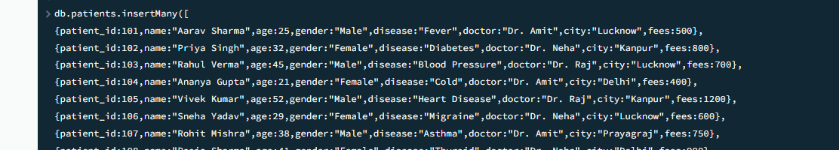
Explanation: Inserts multiple Patients documents into the collection.

4. DISPLAY ALL patients
MongoDB Query:
db. patients. Find ()
Explanation: Retrieves documents from the patients collection.
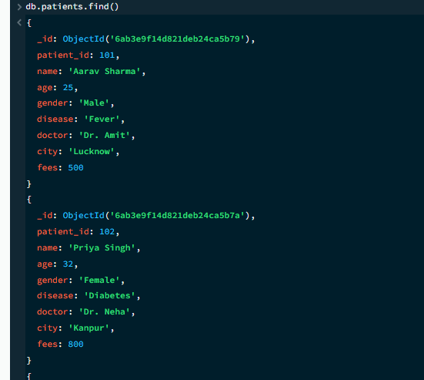
5. EQUAL TO — $eq
MongoDB Query:
db.patients.find({city:{$eq:"Lucknow"}})
Explanation: Finds patients whose city are exactly lucknow.
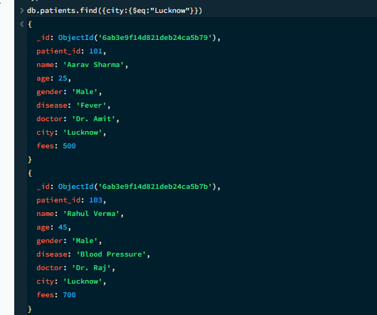

6. GREATER THAN — $gt
MongoDB Query:
db.patients.find({age:{$gt:40}})
Explanation: Finds patients whose age is greater than 40.
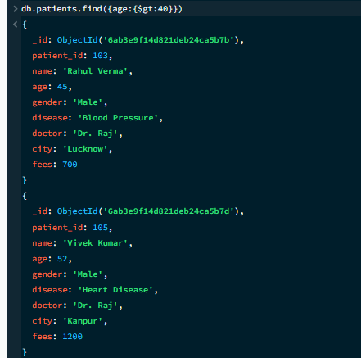

7. LESS THAN — $lt
MongoDB Query:
db.patients.find({age:{$lt:30}})
Explanation: Finds patients whose age is less than 30.

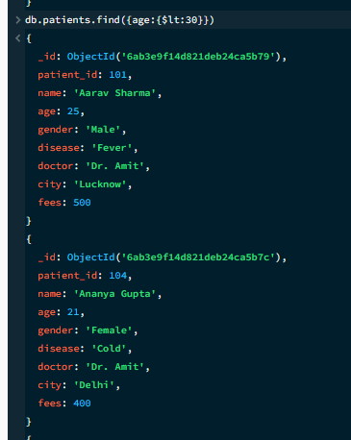
8. GREATER THAN OR EQUAL TO — $gte
MongoDB Query:
db.patients.find({age:{$gte:40}})
Explanation: Finds patients whose age is 40 or above.

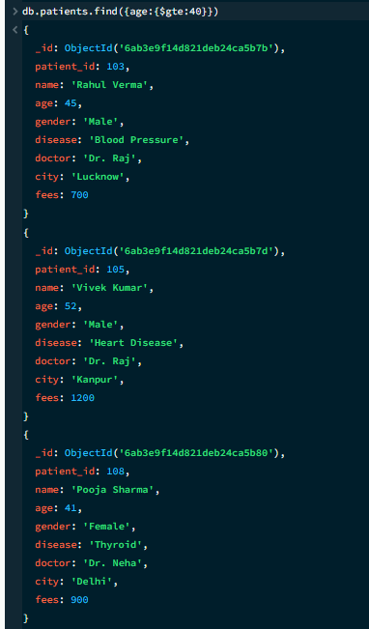

9. LESS THAN OR EQUAL TO — $lte
MongoDB Query:
db.patients.find({age:{$lte:30}})
Explanation: Finds patients whose age is 30 or below.

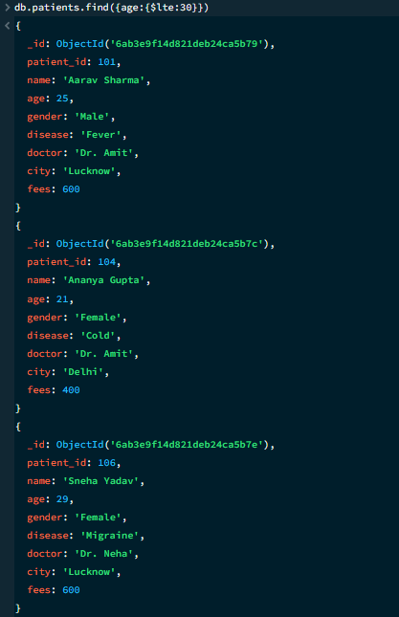

10. UPDATE OPERATION
MongoDB Query:
db. db.patients.updateOne({patient_id:101},{$set:{fees:600}})
Explanation: Updates the fees of patient_id :101 to 600.

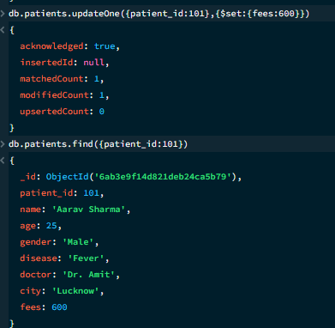

11. DELETE ONE OPERATION
MongoDB Query:
db.patient.deleteOne({patient_id:120})

Explanation: Deletes one document matching patient_id:120.

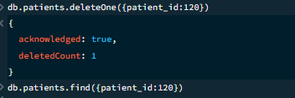

12. DELETE MANY OPERATION
MongoDB Query:
db.patients.deleteMany({age:{$lt:20}})

Explanation: Deletes all patients age less than 20 .

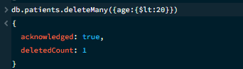

13. AND OPERATION — $and
MongoDB Query:
db.patients.find({$and:[{age:{$gt:30}},{fees:{$gt:700}}]})
Explanation: Finds patients satisfying both conditions.
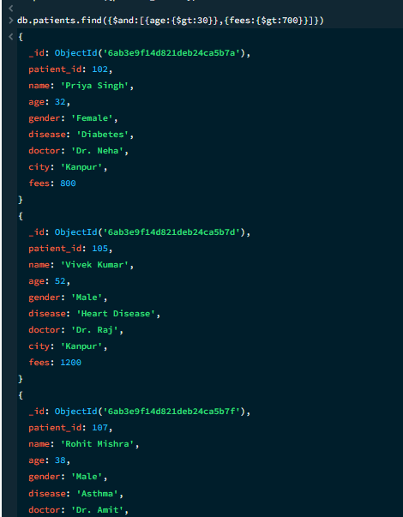
14. OR OPERATION — $or
MongoDB Query:
db.patients.find({$or:[{city:"Lucknow"},{city:"Delhi"}]})
Explanation: Finds patients from Lucknow or Delhi.

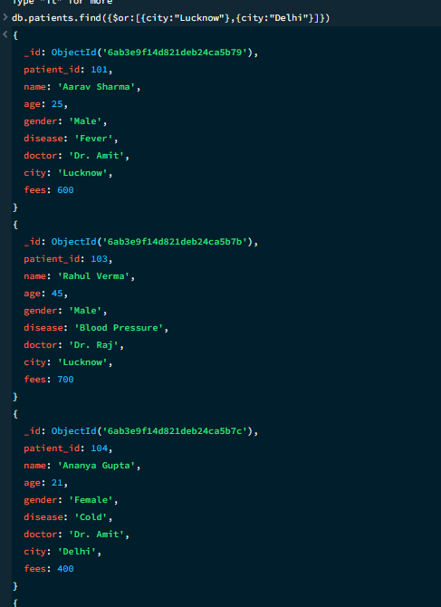

15. SORT OPERATION
A.MongoDB Query:
db.patients.find().sort({age:1})
Explanation: Sorts patients by age from lowest to highest. Use 1 for ascending order.
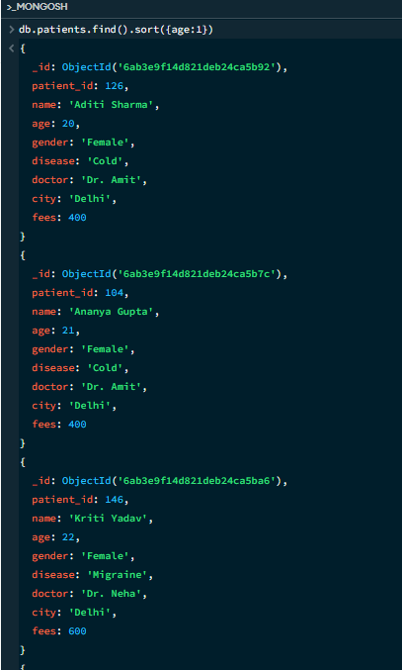

B. MongoDB Query:
db. patients. find (). Sort ({fees: -1})
Explanation: Sorts patients by fees from highest to lowest. Use -1 for descending order.
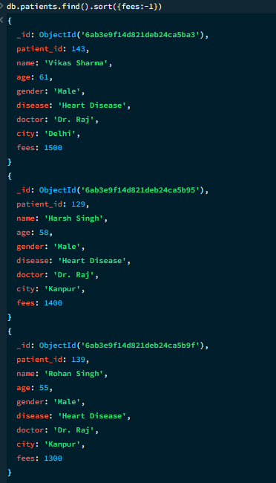

16. LIMIT OPERATION
MongoDB Query:
db. patients. find (). limit (5)
Explanation: Displays only the first five documents.

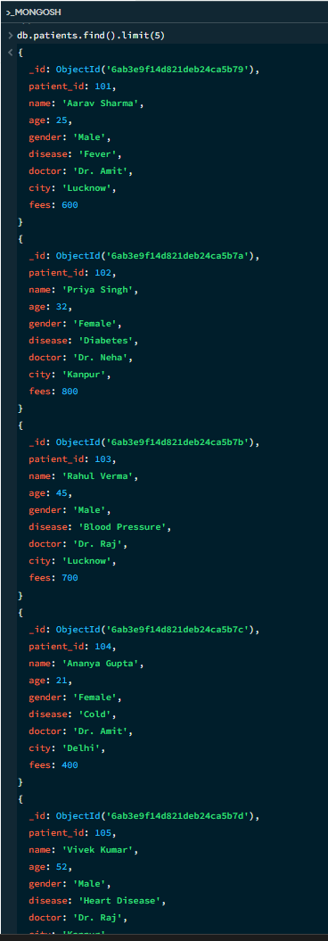

17. SEARCH BY CITY
MongoDB Query:
db.patients.find({city:"Lucknow"})
Explanation: Finds all patients whose city is Lucknow.
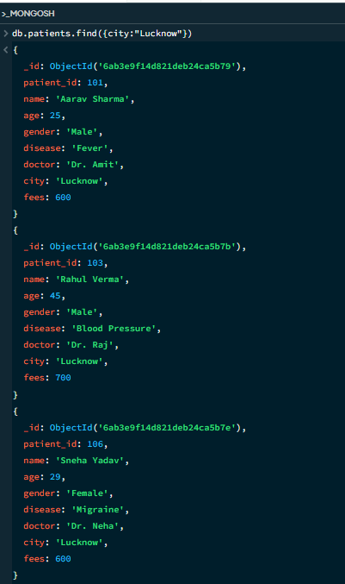

18. COUNT DOCUMENTS
MongoDB Query:
db. patients. count Documents ()
Explanation: Counts documents currently present in the collection (performing after the delete function).
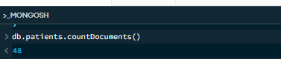

MONGODB OPERATORS USED:

Operator | Meaning | Example
$eq | Equal to | age: {$eq:4}
$gt | Greater than | fees: {$gt:800}
$lt | Less than | age: {$lt:20}
$gte | Greater than or equal to | fees: {$gte:900}
$lte | Less than or equal to | age: {$lte:40}
$and | All conditions true | $and:[...]
$or | At least one condition true | $or:[...]

